GASB 77
2021-22 Tax Abatements

GASB Statement 77 requires disclosure of tax abatement information about (1) a reporting government’s own tax abatement agreements and (2) those that are entered into by other governments and that reduce the reporting government’s tax revenues. GASB 77 requirements are effective for financial statements for periods beginning after December 15, 2015.

Please refer to GASB 77 Summary or GASB 77 Full Text for specific disclosure requirements.

For the purposes of this report, Tax Abatements are defined as resulting from an agreement between a government and an individual or entity in which the government promises to forgo tax revenues and the individual or entity promises to subsequently take a specific action that contributes to economic development or otherwise benefits the government or its citizens.

Of the programs identified, the following have properties in Lane County:
ORS* Tax Expenditure Report**
Enterprise Zone Chapter 285C 2.013
Housing for Low Income Rental 307.515 – 307.535 2.110
Housing; Multiple Unit in Core Areas 307.600 – 307.637 2.108
Nonprofit Corp Housing Assistance 307.241 to 307.245 2.026
Vertical Housing 307.841 – 307.867 2.105

*The Oregon Revised Statutes (ORS) is the codified body of statutory law governing the State of Oregon.

**Oregon’s 1995 Budget Accountability Act requires the governor, with the assistance of the Department of Revenue and the Department of Administrative Services, to produce a tax expenditure report every biennium, along with the Governor’s Budget. Use the links above to navigate to the report and then look up the specific number associated with the exemption. The report includes a description of the exemption, the purpose, who benefits, and provides an evaluation.

The reports contained herein are supplied by the Lane County Department of Assessment and Taxation for the 2021-22 tax year. The information has not been audited, is being provided strictly as a courtesy and is delivered ‘as is’. The individual taxing districts can be contacted for additional information.
There are absolutely no warranties, express or implied, including the warranty of merchantability.

By Exemption Type
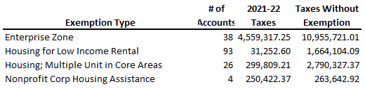

By Taxing District
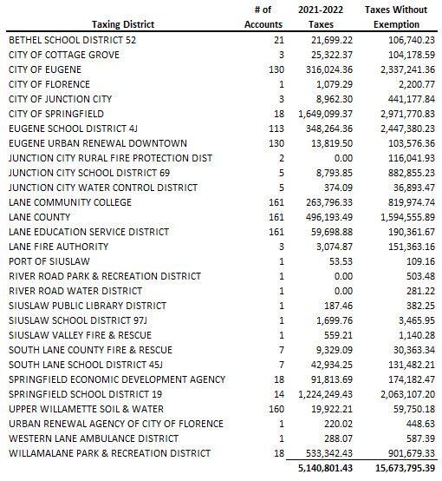

Click here for detailed reports. The following information applies to them:
- The DATA tab contains information by property tax account number.
- A single account affects multiple taxing districts.
- Taxable Value equals the Assessed Value less Exemptions.
- The 2021-22 tax amounts include the compression calculation. Compression is the process of reducing taxes extended on a property so that they fall within the limit of $5 per $1,000 of M5 value for education and $10 per $1,000 of M5 value for general government.
- The levy rates, applied to the Taxable Value, is the Base Tax. If the Tax Limit is lower than the Base Tax, the difference is compressed.
- To calculate the taxes without the listed exemptions, the exempted value was added in to the Taxable Value. Then the taxes were recalculated.
- To calculate the M5 value for accounts with exemptions, apply the same percent the exemption is of the assessed value to the real market value. The difference between that and the real market value is the M5 value to which the limit is applied.

